POSITION: Executive Director (ED)
LOCATION: London, Ontario
POSITION DETAILS: Full Time, Permanent
REPORTS TO: Board of Directors
DIRECT REPORTS: Head of Exhibitions, Collections and Programs; Head of Administration; Director of Finance
WEBSITE http://museumlondon.ca/
CITY OF LONDON: https://www.londontourism.ca/ or : https://london.ca/

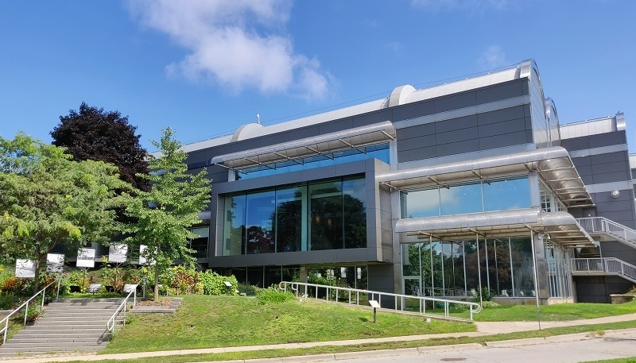

THE ORGANIZATION
Located at the forks of the Thames in downtown London, Ontario, Museum London (ML) is where the communities of London and area discover exceptional art, rich history, and new cultural possibilities. Museum London inspires human experience through art and historical exhibitions, a dynamic mix of responsive public and educational programming, and special events.
At the heart of a great museum is its collection and ML is proud to have one of Canada's most important art collections and one of the most significant historical artifact collections in the province. The ML art collection has more than 5,000 regional and Canadian art works. And 45,000 curated artifacts reflect the history of the City of London as an important regional urban centre in Southwestern Ontario.
Museum London was established in 1940 and operated from the London Public Library until 1980 when renowned Canadian architect Raymond Moriyama was commissioned to design its current home at the forks of the Thames River. In 1989, the then London Regional Art Gallery amalgamated with the London Historical Museum, creating today’s Museum London.
Governed by a Board of Directors elected from community members and representatives, ML is a non-profit charitable organization that acquires and exhibits art and artifacts for the purpose of study, education and enjoyment. Museum London's activities are driven by a mandate to collect, preserve, exhibit and interpret visual arts and local history. ML presents a relevant mix of interconnected exhibitions and programs that have local and national context; exhibitions and programs are often cross-disciplinary, augmented by interpretative material, publications, symposia, discussions, lectures, films or other events. As such, they provide visitors with a range of interactive, interpretive experiences.
The Museum receives significant funding annually from the City of London, the Canada Council for the Arts, and the Ontario Arts Council. And an integral part of ML’s ability to provide engaging experiences is made possible by the financial support of members of the community who are committed to the Museum’s mission and ongoing work.
In the spirit of Truth and Reconciliation, Museum London acknowledges that it operates within the traditional territory of the Anishinaabeg, Haudenosaunee, Attawandaron (Neutral), and Wendat peoples. This territory is covered by the Upper Canada Treaties. This territory is the homeland of the Chippewas of the Thames First Nation, Oneida Nation of the Thames, and Munsee Delaware Nation. ML also recognizes the contributions of Métis, Inuit, and other Indigenous peoples, both in shaping and strengthening London in particular, and Ontario and Canada as a whole.

THE CITY OF LONDON

London, Ontario, proudly known as The Forest City, is home to nearly 400,000 residents. It is a hub for higher education, medical research, manufacturing, and technology.

London is rich in heritage, arts, cultural spaces and natural beauty. Whether you enjoy walking in beautiful parks or along the banks of the Thames River, or if you prefer to visit one of 14 local museums or catch a world-class performance, London offers amenities found in larger cities.

The City of London was founded in 1826. But the story of London’s region goes back much farther. Oral history and archeological records show that the London region has been inhabited for more than 10,000 years. Since its release in 2015, the Truth and Reconciliation Commission Report has acknowledged that “virtually all aspects of Canadian society may need to be reconsidered.” In response, the City of London has been working with local First Nations to educate City staff and the London community about the Indigenous communities that the City serves and is connected to.

THE POSITION

Museum London (ML) is seeking a forward-thinking, energetic, and entrepreneurial leader who will be a visible champion for the organization and its pride of place in the cultural and wider community of London. The Executive Director (ED) will be a transformative champion for Museum London’s exhibition, educational, and program offerings in visual arts and material culture while elevating its stature as a cultural destination for and within London, Ontario.

Advancing the mission, vision, and values of Museum London, the Executive Director will partner with and report to the Board in driving its effectiveness in governance, policy making, and community and donor relations. They will collaborate with the Board and staff to generate revenues and funding, resulting in dynamic and accessible exhibitions and collections. This new leader will be primarily responsible for all aspects of ML’s operations and will be accountable for empowering, guiding, and mentoring a highly motivated team of staff and volunteers.

Partnering with the Board of Directors and staff, the ED will provide strategic direction, executive leadership, and administrative guidance. The ED will be comfortable representing ML to various public bodies and individual stakeholders and will be the public face of Museum London. Committed to advancing reconciliation, equity, diversity, inclusion, and anti-racism for all people, the Executive Director will act as a liaison between the city, artistic communities, Indigenous communities, tourism agencies, and a multitude of distinct yet interrelated public, private, and government stakeholder groups.

The successful candidate will possess the experience, knowledge, and vision in visual arts and material culture along with: a superb operational skillset; exceptional business acumen, a record of success in marketing, audience and donor growth, and fundraising; a demonstrated commitment to strengthening diversity and workplace culture; and a natural inclination towards collaboration and community engagement.

RESPONSIBILITIES
- Provide visionary leadership, including strategic direction and financial sustainability.
- Stimulate and promote excellence and innovation in ML’s programs and exhibitions. Ensure that ML’s programs are relevant to the communities of London and area.
- Develop other revenue sources to ensure sustainability for the future.
- Responsible for ML’s budgets and operational & financial reports.
- Expand connections with the various communities that make up the Greater London area to improve awareness, attendance, and support for Museum London.
- Conceive, develop, and execute the next strategic plan for ML.
- Build and nurture relationships with audiences, communities, partners, major donors and funders, and other stakeholders.
- Represent ML to the wider communities of London and area and act as a public advocate for ML to encourage potential stakeholders and donors as well as appropriate government agencies to continue and increase their support of ML.
- Play a leading role within the local arts and cultural community sector.
- Manage ML’s resources – human, financial and physical – so as to strengthen the Museum’s pre-eminent role in an increasingly competitive environment.
- Ensure the critical relationships with the City of London and relevant agencies of the Governments of Ontario and Canada remain strong.
- Promote the commitment to diversity, equity and inclusion within the staff, Board and audiences while deepening ML’s engagement with BIPOC communities and other under-represented groups.
- Create an inviting and relevant environment in ML’s spaces that will attract and engage the wider diversity of community.
- Deliver on ML’s commitment to reconciliation and inclusivity in the representation, presentation, and interpretation of Indigenous stories and experiences at the Museum.
- Provide regular reports to the Board on financial and other matters; keep the Board informed of any actions which may affect the Museum.
- Oversee day-to-day administration and management in accordance with goals, initiatives, policies and budget limitations established by the Board.
- Ensure that effective financial control and sound accounting practices are in place, monitor expenditures in relation to budget and to actual income.
- Develop and maintain corporate, private foundation, government and community sponsorships and partnerships.
- Ensure effective recruitment, orientation, training and development of staff and volunteers.
- Develop a culture that promotes respect and teamwork, builds loyalty, drives engagement, and maximizes employee potential and appeals to outside talent.

CANDIDATE QUALIFICATIONS
- Demonstrated track record of cultural leadership and administration; minimum 10 years of senior leadership in a similar or other relevant organization.
- An engaging and collaborative visionary who can ensure delivery of captivating annual exhibitions, educational and outreach programs, while staying true to the principles of ML and its accessibility initiatives.
- An innovative thinker who uses digital technologies to further the impact on audiences and patrons.
- Brings an understanding of marketing, including the uses of social media to drive attendance and engagement.
- An exceptional fundraiser with a track record of successful stewardship with donors, Board Members, stakeholders, sponsors, and other partners.
- A keen and impactful spokesperson helping to foster appreciation of the organization, with an aligned belief in the mission of ML.
- An excellent relationship builder who engenders trust and confidence with all stakeholders and wider community members.
- Experience working and collaborating effectively with and reporting to boards.
- Significant experience leading and managing in a unionized environment.
- A demonstrated commitment to equity, diversity and inclusion in all aspects of Museum London and its operations.
- Knowledge of or willingness to understand the history and pre-history of the unique and diverse First Nations and Metis communities of the London area.
- Operational experience in managing a cultural facility of similar size to ML with teams of staff and volunteers.
- A fiscally savvy leader, with a track record of delivering balanced budgets.
- Exceptional ability to foster a collaborative and open-door culture with staff and the Board.
- Bilingualism is an asset.

CANDIDATE ATTRIBUTES
- Culturally aligned with ML’s mandate, mission, and vision.
- Genuine and keen interest in the arts, culture, history and heritage of Southwestern Ontario.
- Strong interpersonal and communications skills.
- The ability to engender confidence and trust from the cultural community, staff, Board and government.
- Highly articulate, with exceptional team-building skills.
- Creative and strong leadership skills, internal and external.
- Enjoys mentoring people and helping to achieve agreed upon goals.
- High professional standards and integrity.
- A practical, calm, and creative problem solver and strategic thinker, who can react nimbly to the unexpected and be flexible in their decision-making.
- Ability to work well under pressure, independently or as part of a team.
- Results-oriented and disciplined; accepts ownership with a hands-on approach.
- Active listener, with a collegial management approach.

COMPENSATION
A competitive compensation package will be offered, complete with salary and benefits.

HOW TO APPLY

Please apply by email with your cover letter and resume by no later than October 15th, 2021. Send to: ML@searchlightpartnersgroup.com
Museum London is strongly committed to employment equity and welcomes diversity in its community. We welcome all applications from racialized persons/persons of colour including Indigenous peoples, persons with disabilities, persons of all sexual orientations and gender identities, and others who may contribute to the further diversification of ideas. Accommodations will be made available to applicants with disabilities in the recruitment process. If you require accommodation, please contact ML@searchlightpartnersgroup.com.
We thank all applicants for their interest; however, only those being considered for interviews will be contacted by Searchlight Partners.

