MUSEUM | LONDON

Lesson Plan – Landscape Art
Subject: Visual Art | Teacher:
Grade Level: Kindergarten (JK/SK) | Date:
Topic: Group of Seven Landscape Planes | Timeframe:

Ontario Curriculum Expectation(s)
V1.1 – demonstrate an awareness of personal interests and a sense of accomplishment in visual arts
V2.1 – explore a variety of tools, materials, and processes of their own choice to create visual art forms in familiar and new ways
V2.2 – explore different elements of design (e.g., colour, line, shape, texture, form) in visual arts

Learning Goal
Students will…
-be introduced to visual planes within a landscape painting (foreground, middle ground, background)
-learn how to integrate patterns and utilize colour in the various visual planes

Materials/ Resources
-White paper
-Acrylic paints
-Paint brushes
-Crayons
-Pencils
-Q-tips
-Cotton balls
-Coloured construction paper
-Tissue paper
-Magazines
-Scissors
-Glue sticks
www.laughpaintcreate.blogspot.ca
-Museum London Artwork can be referenced online at http://visiblestorage.ca/

Differentiated Activities:
-scented play dough
-multiple colours of plasticine
-thick paper or cardboard for base of plasticine landscape

Lesson
Introduction:
-introduce various Group of Seven landscape paintings and ask students…
- how they would feel if they were in each painting
- which colours they see and like the best/ the least
- what they see (trees, water, sky, etc.)
-discuss the different areas that a landscape has: grass, flowers, trees, water, mountains, sky
-introduce activity to students by showing a prototype and cutting a piece of white paper into four sections
-together with the students, choose 4 different areas that you want your landscape to have
-brainstorm together how you might create the different areas (by using paint, crayons, collage, pencil)
-demonstrate how the pieces of the landscape will be glued onto a background colour when each section has dried
Body:
-Students will receive a white piece of paper which they will draw three lines across in order to cut into four sections (encourage them to think about drawing a curvy line if they are including mountains, or a jagged line if they are including grass)
-Provide various materials per group of students and encourage students to use whichever medium they think might work the best for each section
-Allow artwork to dry
Conclusion:
-Glue various sections of the landscape onto coloured construction paper
-Choose volunteers to show their artwork in front of the class and talk about what they have included, encouraging other students to also ask them questions about their work

Differentiation
Visually impaired students: provide student with scented play dough and instruct them to think of something in nature that they want to create out of the medium
Impaired motor skills: students may wish to create a plasticine landscape on a piece of thick paper or cardboard

Assessment and Evaluation
-Review student artwork and through the form of a checklist, note if students have…
-included four sections within their landscape
-experimented with colour, pattern, or media

Art Resources

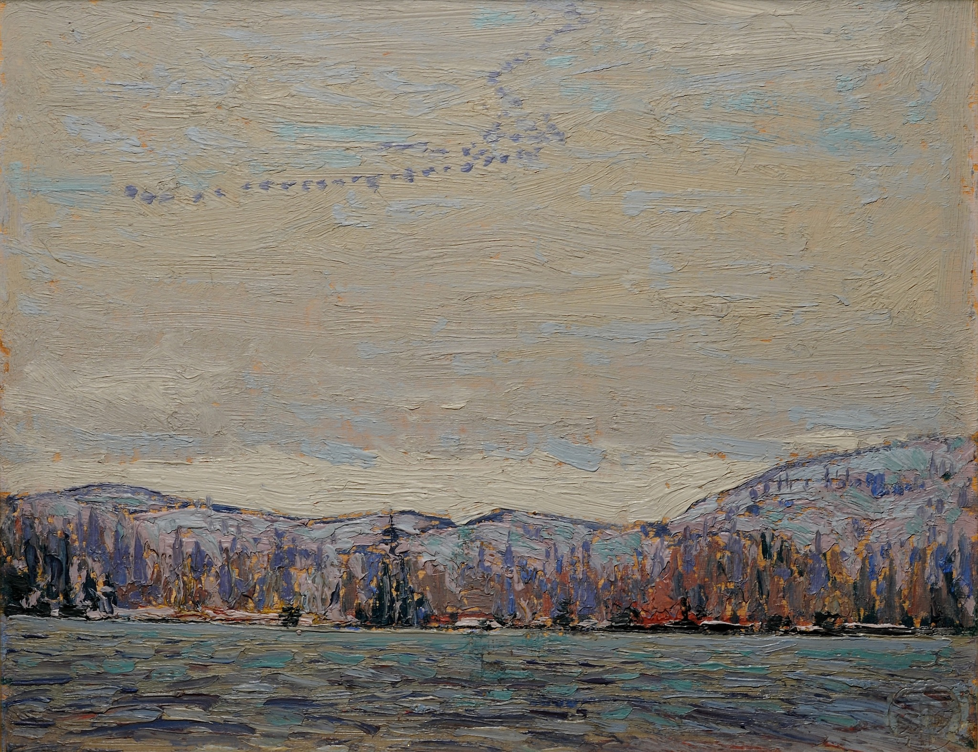
Wild Geese, Tom Thomson, Oil on Wood Panel, 1916, 21 x 27cm

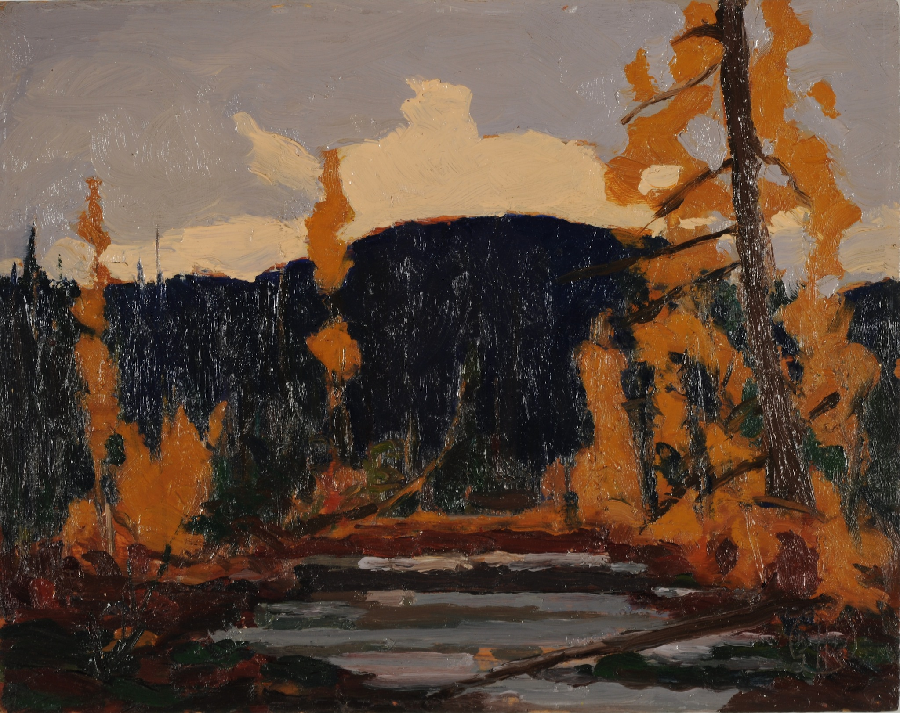
Untitled Sketch, School of Tom Thomson, Oil on Wood Panel, Not Dated, 21 x 26.7cm
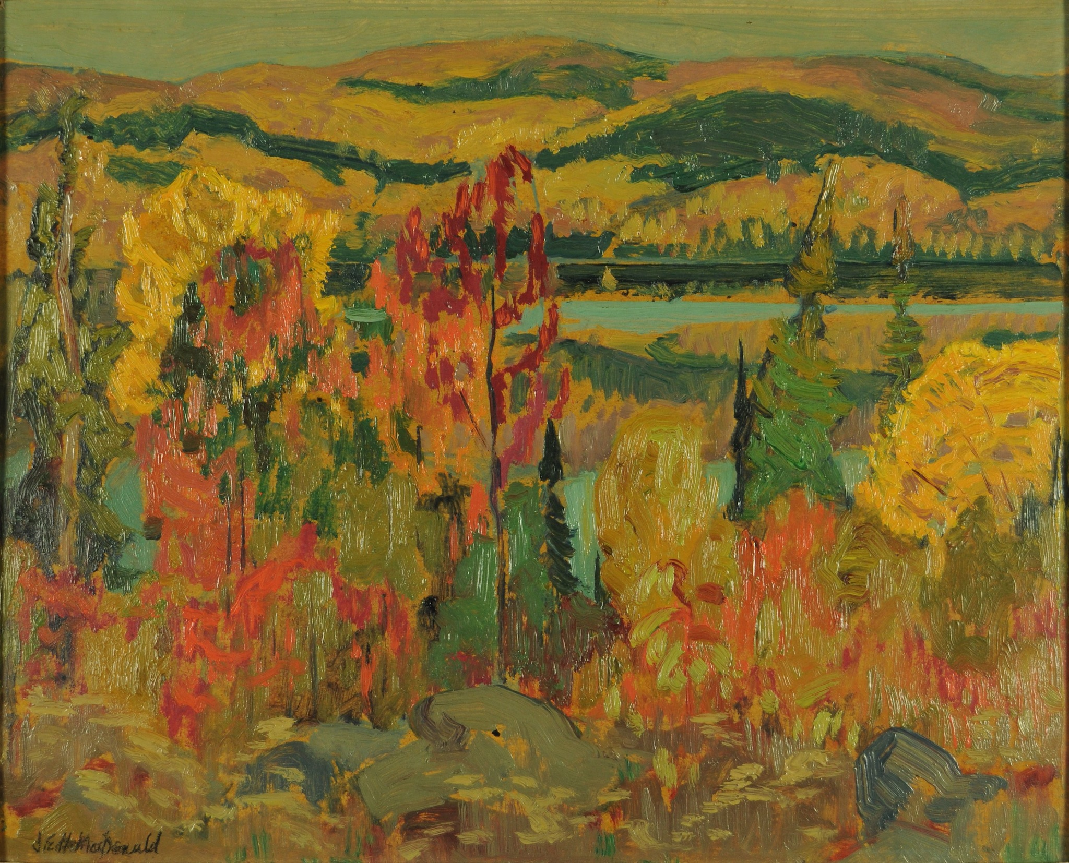
Mongoose Lake, Algoma, J.E.H. MacDonald, Oil on Heavy Card, 1920, 22 x 22.7cm

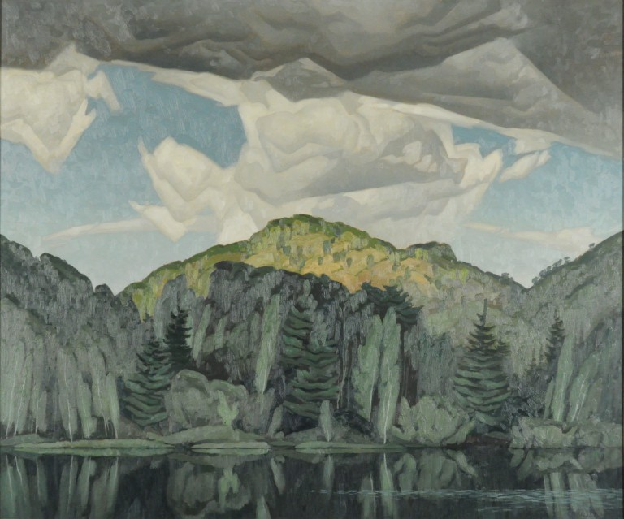
Bedard Pond, Alfred Joseph (A.J.) Casson, Oil on Masonite, 1960, 75 x 89.5cm

1. 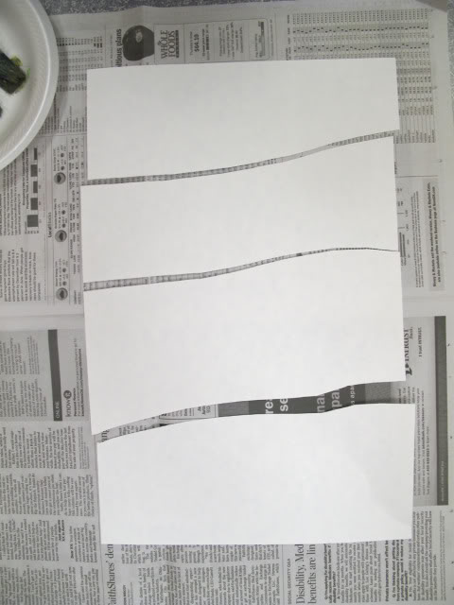 2. 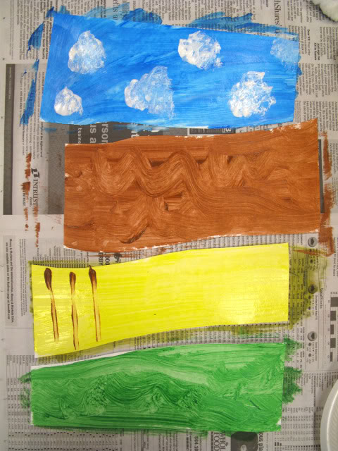

3. 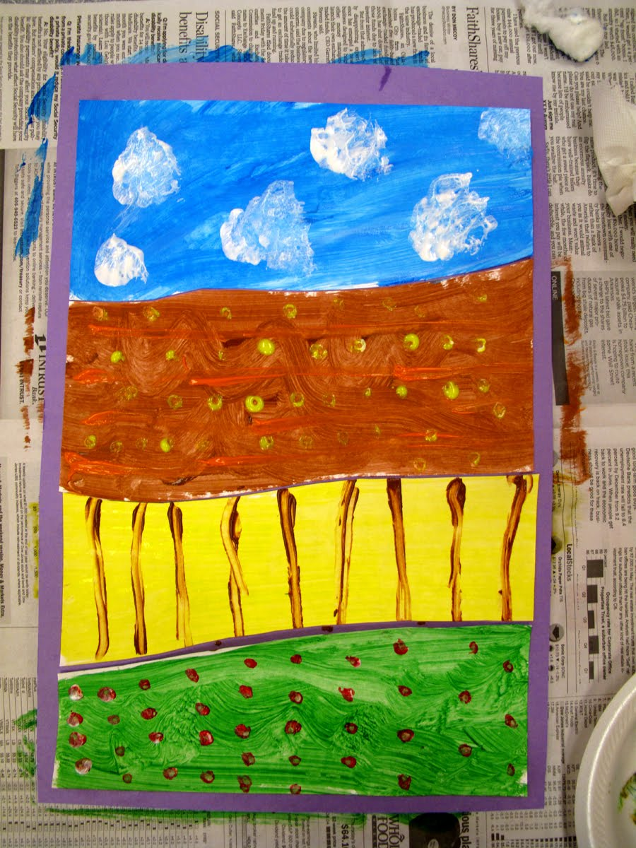

www.laughpaintcreate.blogspot.ca

