Lesson Plan – Exploring Abstraction
Subject: Visual Art | Teacher:
Grade Level: Kindergarten (JK/SK) | Date:
Topic: Abstract Art | Timeframe:
MUSEUM | LONDON

Ontario Curriculum Expectation(s)
V1.1 – demonstrate an awareness of personal interests and a sense of accomplishment in visual arts
V2.1 – explore a variety of tools, materials, and processes of their own choice to create visual art forms in familiar and new ways
V2.2 – explore different elements of design (e.g., colour, line, shape, texture, form) in visual arts

Learning Goal
Students will…
-learn to communicate experiences and feelings through artistic, abstract expression
-learn the freedom of abstract art, and that as an artist, your art can mean anything you want it to mean

Materials/ Resources
-SMARTboard or projector (to show painting reference)
-Student-grade watercolour paper
-Oil pastels
-Watercolour paints
-Paint brushes
-Containers for water
-(optional) rags/ paper towels for excess water when painting
www.laughpaintcreate.blogspot.ca

Differentiated Activities:
-Styrofoam plates
-carving tools (pencil, paper clip, etc.)
www.jacksonpollock.org

Lesson
Introduction: (5-10 min.)
-Introduce Marian Scott’s Stone and Protoplasm #2 and discuss what abstract art is
-Explain that abstract art should not look like things that we see around us, but instead should look like feelings, ideas, thoughts, or stories (if we could see them), by using colours, shapes and lines
-Ask students what they see in the painting, and what they think Scott was thinking about or feeling when she painted Stone and Protoplasm #2
-Emphasize that nothing is wrong when it comes to abstract art – the artist may have painted their picture to mean something, but when we look at a painting, we don’t know that meaning, so to us, it can mean anything.

-Demonstrate how feelings or stories could be made into an abstract piece of art on a SMART board, anchor chart, or large drawing surface (think about how you are feeling and what you have done during the day, and how these things might look if they were translated into colours, lines, or shapes). Ex. Happiness could be expressed through the colour yellow, with quick, short lines. Or, if you had cereal for breakfast, you might draw circles to represent a cereal bowl.

Body: (20-25 min.)
-inform students that they will be creating their own abstract artworks, first by drawing onto paper, and then painting over the top of their drawing (oil pastels will repel watercolour paints, so the drawing will still be seen after the paints are applied)
-provide a set of oil pastels per every few students
-students will create an abstract drawing on watercolour paper, using various colours
-encourage students to allow themselves to be led to whatever colour, shape, line, or idea that comes to their mind as they develop their piece, not dwelling too much on how it’s looking, but rather what comes to mind
-when students have completed their drawing, provide them with several watercolour paints, a brush, and a shallow dish of water (optional: rags/paper towels)
Conclusion: (5 min.)
-students will clean up their area and place their artwork on their desk
-ask students if any of them have been to a museum or gallery before
-if so, ask them to share rules that people need to remember when they visit a museum (always walk, respect the artwork by not touching it, be quiet so that people around you can focus on enjoying the art)
-tell students that the classroom has now become a pretend museum, and they will walk around the desks to look at all of the beautiful work that has been made
-if time permits, ask students to choose someone else’s painting and share with the class why they liked it

Differentiation
Visually impaired students: have students carve into a piece of Styrofoam in order to represent their feelings, thoughts, or a story through line and shape. Students will be able to feel the marks on the surface after their piece is complete.
Impaired motor skills: students may access www.jacksonpollock.org in order to create abstract artwork through a drip-painting program.

Assessment and Evaluation
-individual interviews with students will allow assessment through the form of a checklist based on:
-whether or not they can explain an element of the painting (why they chose certain colours, or what various components of the painting mean to them)
-whether or not they experimented with various shapes, lines, or colours, rather than recognizable figures/objects such as a house or a dog
-whether or not they behaved well in the studio (classroom) while creating their work

Art Resources

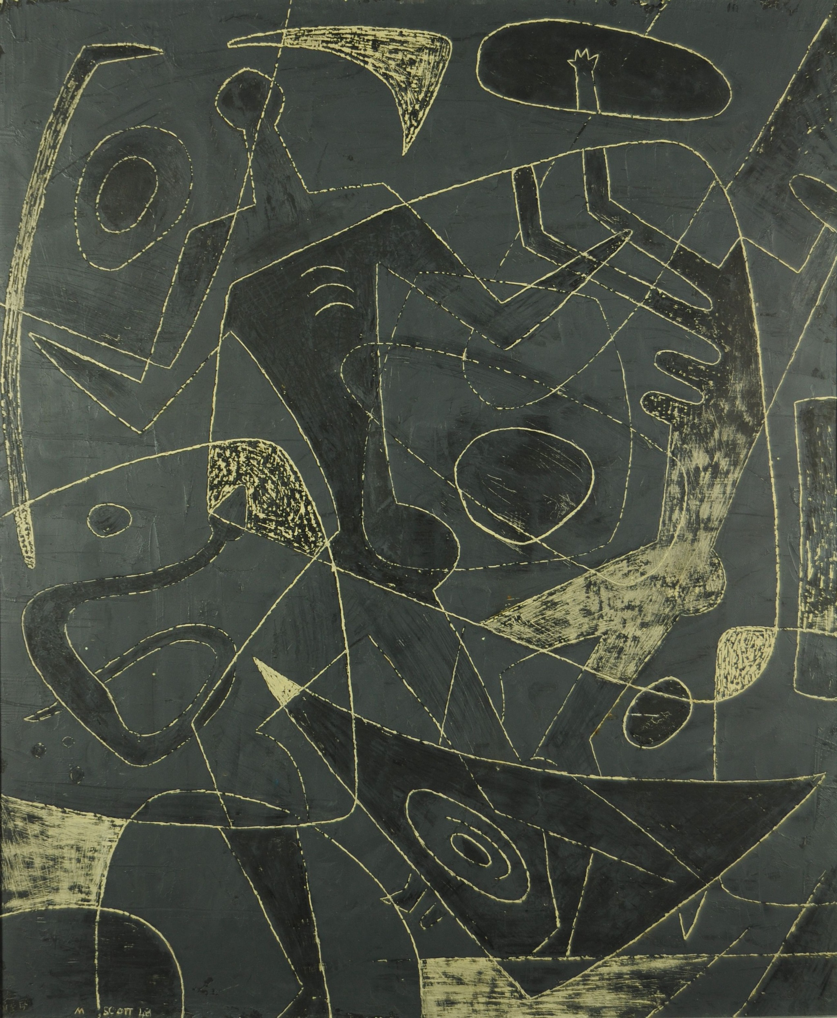
Stone and Protoplasm #2, Marian Scott, Oil on Masonite, 1948, 61 x 50.8 cm

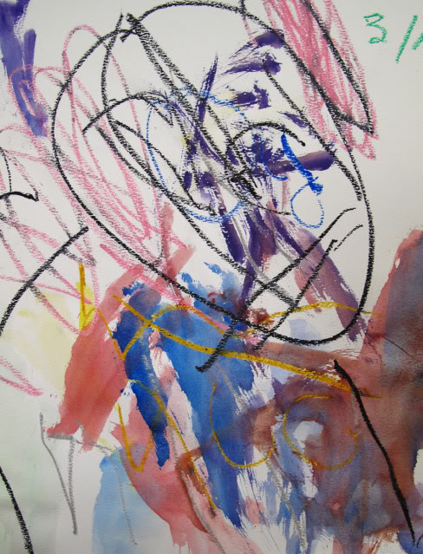
www.laughpaintcreate.blogspot.ca

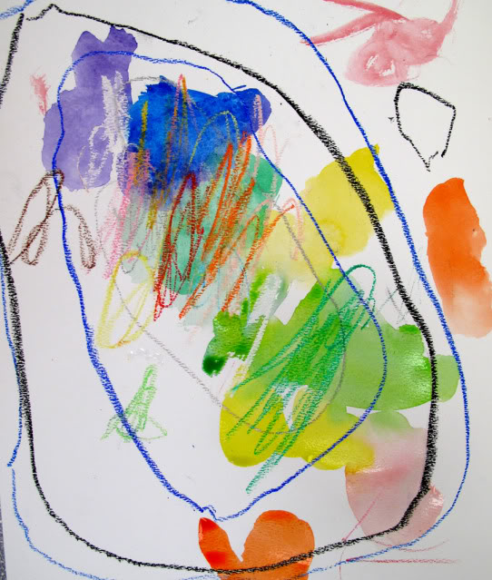
www.laughpaintcreate.blogspot.ca

