Lesson Plan Information
Subject: Art | Name:
Grade: Five | Date: | Time:
Topic: Proportion | Period Length:

Expectations
Curriculum Expectations (Based on the Ontario Curriculum Documents):
D1.1 create two- and three-dimensional art works that express feelings and ideas inspired by their own and others’ points of view
D1.4 use a variety of materials, tools, and techniques to determine solutions to design challenges
Learning Skills (Where necessary):

Content
What learners will know/be able to do:
Learners will discover how proportion is essential to creating realistic looking art by making objects in the background of an image smaller than those in the foreground. They will learn techniques to draw the same picture using different sizes.
Today learners will:
Identify proportion in Museum London artwork. Create a drawing of the same image 3 times across a diagonal from an upper corner of the page to a lower corner. The image closest to the lower corner will be largest (closest to the eye) while the image towards the top corner will be the smallest (further away).

Assessment and Evaluation
Determining student understanding:
The students will hand in artwork, exhibiting 3 distinctly different sizes of the same shape or drawing.

Perspective
Necessary Prior Knowledge:
Students will have prior knowledge of the elements and a few of the principles. They will be concentrating on the principle of proportion.
ELEMENTS OF DESIGN
Students will develop understanding of all elements of design.
• line: linear and curved hatching and cross-hatching that add a sense of depth to shape and form; gesture drawings; chenille stick sculptures of figures in action; implied lines for movement and depth
• shape and form: symmetrical and asymmetrical shapes and forms in font and image; positive and negative shapes that occur in the environment; convex, concave, non-objective shapes
• space: shading and cast shadows that create the illusion of depth; atmospheric perspective; microscopic and telescopic views
• colour: complementary colours, hue, intensity (e.g., dulling, or neutralizing, colour intensity by mixing the colour with a small amount of its complementary hue)
• texture: textures created with a variety of tools, materials, and techniques; patterning • value: gradations of value to create illusion of depth, shading
PRINCIPLES OF DESIGN
Students will develop understanding of all principles of design (that is, contrast, repetition and rhythm, variety, emphasis, proportion, balance, unity and harmony, and movement), but the focus in Grade 5 will be on proportion.
• proportion: the relationship of the size and shape of the parts of a figure to the whole figure; the scale of one object compared to its surroundings, with indications of how close and how large the object is (e.g., figures with childlike proportions that are approximately “five heads high” and adult figures that are approximately “seven or eight heads high”; caricature; use of improbable scale for imaginary settings and creatures)
Differentiation:
Visually impaired students can write 3 versions of a short story. A “bare bones” version that is only one paragraph and has very basic details. A two-paragraph version of the same story with more details, and a three paragraph version of the same story which includes the most amount of detail. The student can then explain why each version has its use, for example: a very simple story is useful when trying to summarize to someone unfamiliar with the story. The medium-detailed story is good for a quick read, and the more detailed one is great for getting information.
Impaired motor skills students may use the computer to create the same art piece by resizing images against an interesting background to show understanding.
Environment:
This lesson will be completed in a normal classroom setting.
Resources/Materials:
Museum London Artworks:
(the following artworks can be accessed by going to the Museum London website http://museumlondon.ca/ and searching for them on the “collections” page – type in the names of the artists)
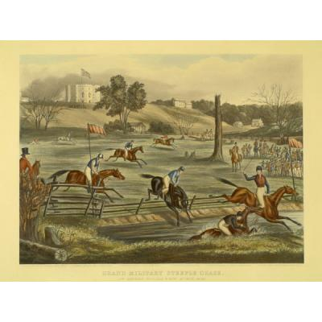
Grand Military Steeplechase at London, C.W., 9th May, 1843 by Eveline Marie Alexander, 1845

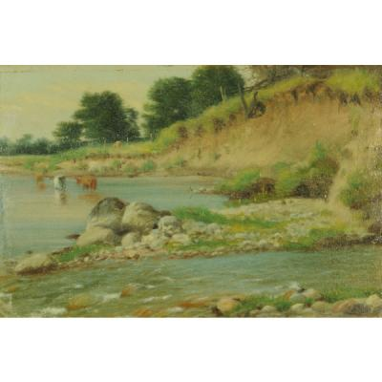
Cattle Watering, Thames River by John Powel Hunt, n.d.

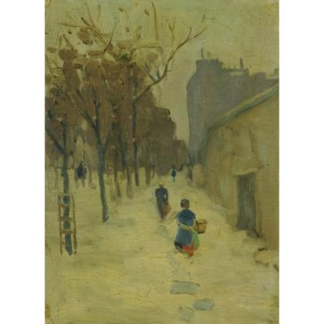
Winter Street Scene by J.W. Morrice, n.d.
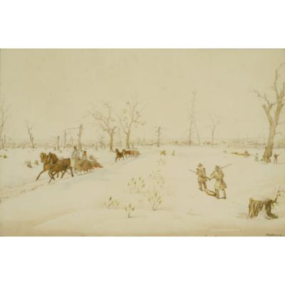

London, Canada West by Peter Valentine Wood, 1842

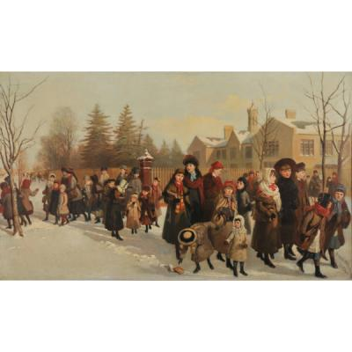
The Return from School by F.M. Bell-Smith, 1884

Graphing paper
Large white sheet of paper
Pencils
Markers
Windows
Tape
Pencil Crayons

Strategies
Introduction:
The teacher will ask students to define proportion and guess what it means when applied to art. The teacher will show each Museum London artwork and discuss with the class how proportion is shown by having closer images appear bigger than those further away. The teacher will discuss how this creates a sense of space.
Climax:
Students will use graphing paper to draw a simple outline of a shape that is either organic or geometric on graph paper in a square that holds 9 1x1 squares. They will then draw the same picture in a square containing 36 1x1 squares, and then once more using 81 1x1 squares. When drawing in the 36 squares, have students split the 36 into 9 4x4 squares to create the one large square so that they may draw their original sketch proportionately. The 81 1x1 squares will be converted to 9 squares of 1x1 to create the large square to sketch in. This should result with 3 pictures of the same shape, using different proportions. Teachers may choose to prepare the squares for the students to avoid confusion.
Conclusion:
Students will outline their sketches in black marker. They will then tape the three sketches against the window in a diagonal. Students will tape their large sheet of white paper over top of the three sketches and trace over the lines from the 3 proportional sketches in pencil. Once done, the students may outline the 3 sketches on the large sheet of paper in any coloured marker they choose and colour them in with pencil crayon if they want to.

