Lesson Plan Information
Subject: Language Arts and Visual Arts | Name:
Grade: Five | Date: | Time:
Topic: Reading Poetry | Period Length:

Expectations
Curriculum Expectations (Based on the Ontario Curriculum Documents):
  - read a variety of texts from diverse cultures, including literary texts
1.3 identify a variety of reading comprehension strategies and use them appropriately before, during, and after reading to understand texts
Learning Skills (Where necessary):

Content
What learners will know/be able to do:
Students will learn how specific word use can paint a different picture when used in poetry. A sentence written as: “I was angry when I fell down” has a completely different feel than the line “I grumbled when I stumbled and tumbled to the ground”.
Today learners will:
Learn how wording affects the imagery of a text, especially poetry. Different words with similar meanings evoke different moods. Students will hear two poems and discuss with the class the images they think about when hearing each poem. They will then see the accompanying artwork from Museum London and discuss in which ways the pictures relate to the poem, and how they differ from the meaning of the poem.

Assessment and Evaluation
Determining student understanding:
Students will determine their understanding by creating a poem that effectively represents the artwork their partner created.

Perspective
Necessary Prior Knowledge:
Students must have already been introduced to basic poem structures.
Differentiation:
Visually impaired students may choose to write a poem based on a story they like.
Environment:
This lesson will be taught in a normal classroom setting.
Resources/Materials:
Tea With Aunty Mabel: Poem by Jeanne Willis
If you ever go to tea with my Aunty Mabel,
Never put your elbows on the dining room table,
Always wipe your shoes if you’ve been in the garden,
Don’t ever burp. If you do, say pardon.
Don’t put your feet on the new settee,
If she offers you a sugar lump, don’t take three.
Don’t dunk your biscuits, don’t make crumbs,
Don’t bite nails and don’t suck thumbs.
Don’t rock the budgie, don’t tease the peke,
Speak when you’re spoken to or else don’t speak.
Do as you’re told and if you’re not able,
Don’t go to tea with my Aunty Mabel.
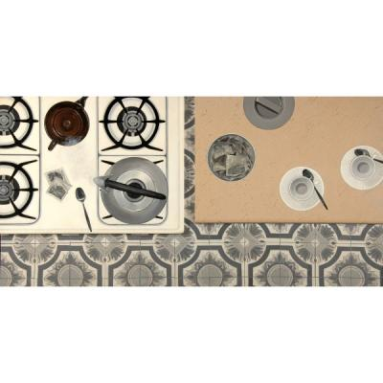
Tea Ceremony, by Bernice Vincent, 1977 to accompany Tea with Aunty Mabel by Jeanne Willis.
(the above artwork can be accessed by going to the Museum London website http://museumlondon.ca/ and searching for it on the “collections” page – type in the name of the artist)

The Quarrel: Poem by Leanor Farjeon
I quarreled with my brother
I don’t know what about,
One thing led to another
And somehow we fell out.
The start of it was slight,
The end of it was strong,
He said he was right,
I knew he was wrong!
We hated one another.
The afternoon turned black.
Then suddenly my brother
Thumped me on the back,
And said “Oh, come along!
We can’t go on all night
I was in the wrong.”
So he was in the right.

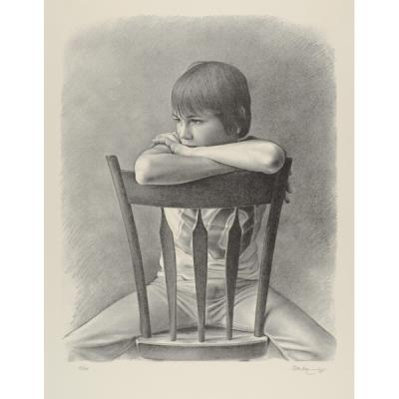
Boy in Chair, by Ken Danby, 1975 to accompany The Quarrel by Leanor Farjeon.
(the above artwork can be accessed by going to the Museum London website http://museumlondon.ca/ and searching for it on the “collections” page – type in the name of the artist)

White Paper
Oil Pastels

Strategies
Introduction:
The teacher will refresh the students on basic forms of poetry such as Acrostic, Free style and Haiku. They will discuss popular rhyming schemes and then read the poem Tea With Aunty Mabel. They will discuss what imagery they visualize when they hear the poem and then view the artwork Tea Ceremony by Jeanne Willis. Students will then discuss how the artwork does or does not accurately represent the poem. Students will do the same for the poem The Quarrel by Leanor Farjeon and the artwork Boy in Chair, by Ken Danby.
Climax:
Students will draw any scene they want. This scene can be a landscape, cityscape, underwater setting or animals, plants, people, etc. The picture must be completely coloured and have a foreground, middle ground and background.
Conclusion:
Once complete, students will exchange their art with another student. They will observe their peer’s picture and write a poem that uses words that successfully describe the art they were given. Students will then present the picture they were given and read their poem discussing the words they used to describe the art.

