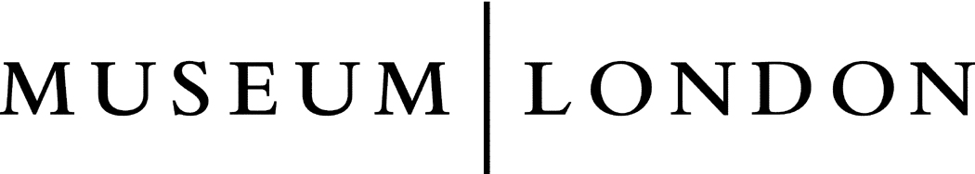
Lesson Plan Information
Subject: Social Studies and Art | Name:
Grade: Four | Date: | Time:
Topic: Canadian Natural Resources | Period Length:

Expectations
Curriculum Expectations (Based on the Ontario Curriculum Documents):
Knowledge and Understanding:
– identify the natural resources necessary to create Canadian products, and the provinces and territories from which they originate
Learning Skills (Where necessary):

Content
What learners will know/be able to do:
Students will learn to recognize where the natural resources of Canada come from and how they are traded and used to create the products we use every day. Students will learn about some of the main natural resources that are harvested in Canada.
Today learners will:
Be introduced to the concept of natural resources used in Canada. They will observe artwork from Museum London and attempt to recognize the resources in each artwork. They will learn about what products are made with these resources. Students will write two paragraphs about an item they use which uses Canadian natural resources. Afterwards, the students will create a piece of art using torn tissue paper glued onto white paper or construction paper to represent a natural resource.

Assessment and Evaluation
Determining student understanding:
Students will demonstrate understanding by writing about a natural resource they use in a product. They will also demonstrate understanding by creating artwork to represent a natural resource.

Perspective
Necessary Prior Knowledge:
Students should have some knowledge about Canadian Geography.

Differentiation:
Students with visual impairments may choose to write or verbally present about a natural resource that they use in a product or device.
Environment:
This lesson will take place in the normal classroom setting.
Resources/Materials:
Museum London Artworks:
(the following artworks can be accessed by going to the Museum London website http://museumlondon.ca/ and searching for them on the “collections” page – type in the names of the artists)

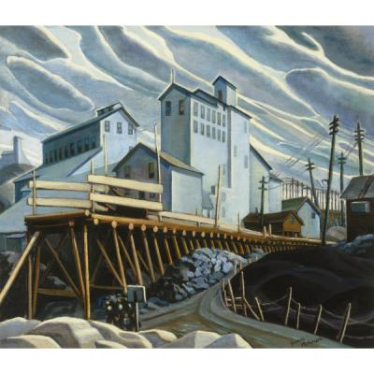
Silver Mine, Cobalt by Yvonne McKague Housser, 1930

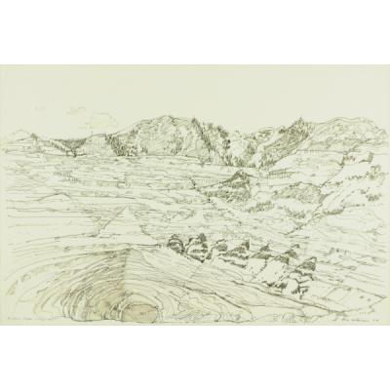
Bingham Copper Mine by Eric Atkinson, 1993

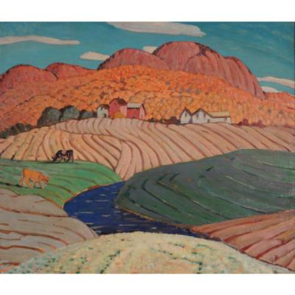
Hillside Farm, Bolton Pass by Albert Henry Robinson, 1930

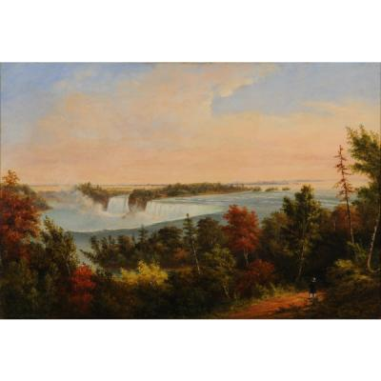
Niagara Falls from the British Side by Cornelius Krieghoff, 1856

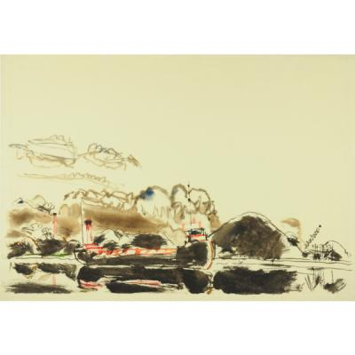
Unloading Coal by David Milne, 1941

Strategies
Introduction:
The teacher will ask students what they believe a natural resource is. Natural resources will be introduced, and the class will brainstorm what they believe are our natural resources. Students will be shown the artwork from Museum London and identify the resources in each artwork. Students will then learn about some of Canada’s major natural resources, like crude oil, grains and wheat, metals, minerals, lumber, etc.
Climax:
Students will be asked to write two paragraphs about a natural resource that is used in a product that they use regularly. For example, a student may choose to write about how their kitchen table is made out of wood, which comes from trees as part of the lumber industry. The student can also state how a tree is made into a table, and that the wood is cut, sanded, cleaned, stained, glued, nailed and screwed to form a table. Students will then use torn tissue paper to represent a natural resource and at least one product from that resource by pasting onto another piece of paper. A student may choose to represent lumber by forming trees, paper, houses, etc.
Conclusion:
Students will be asked to present their artwork to the class to explain how they represented a natural resource and a product of that resource.

