Lesson Plan Information
Subject: Art | Name:
Grade: Four | Date: | Time:
Topic: Art Emphasis | Period Length:

Expectations
Curriculum Expectations (Based on the Ontario Curriculum Documents):
D1.1 create two- and three-dimensional works of art that express feelings and ideas inspired by their interests and experiences
D1.4 use a variety of materials, tools, and techniques to determine solutions to design challenges
Learning Skills (Where necessary):

Content
What learners will know/be able to do:
Learners will know how to recognize the principle of art emphasis when observing artwork. They will learn how to create emphasis in their own artwork and how emphasis is used in ads from magazines.
Today learners will:
Be introduced to the principle emphasis and discuss how it is created and how it is important in artwork. Students will discover emphasis by viewing art from Museum London. Students will then look through old magazines to find ads that feature emphasis. The students will be required to use oil pastels and pieces of construction or tissue paper to create a picture that clearly depicts emphasis. They may draw whatever they would like, as long as the emphasis is clear. They may choose to do abstract or realistic art.

Assessment and Evaluation
Determining student understanding:
Students will hand in a picture that clearly depicts emphasis. They will also present their art to their classmates and explain where they used emphasis and how they created it.

Perspective
Necessary Prior Knowledge:
Students should already know the elements of art, though review may be necessary, and will concentrate on the principle of art “emphasis” in grade 4.
ELEMENTS OF DESIGN
Students will develop understanding of all elements of design.
• line: lines to indicate emotion (e.g., smooth, horizontal lines can give a feeling of peace and harmony); contour lines (e.g., edges of objects); lines of various weights; repetition of lines to create visual rhythm
• shape and form: free-standing forms “in the round” (e.g., Henry Moore’s figurative work) and “bas relief sculpture” (e.g., masks); shapes organized in a pattern showing radial symmetry and/or in a mosaic; changes in shapes, depending on the angle or point of view (e.g., view from the top, side, bottom); positive and negative shapes (e.g., closed curve with shape inside and outside); grouping of shapes; abstract shapes and forms
• space: positive and negative space in art work; diminishing perspective in various contexts (e.g., in vertical placement, in diminishing size, and/or in overlapping shapes); variation in size to create the illusion of depth
• colour: monochromatic colour scheme; colour emphasis through variations in intensity (e.g., subdued colours next to bright, intense colours); advancing colour
• texture: texture elaboration (e.g., embossing, piercing, pinching, pressing, scoring, scraping); texture quality (e.g., matte, sheen); low relief in collographs
• value: mixing of shades; variations in value to create emphasis (contrast in value)
PRINCIPLES OF DESIGN
Students will develop understanding of all principles of design (that is, contrast, repetition and rhythm, variety, emphasis, proportion, balance, unity and harmony, and movement), but the focus in Grade 4 will be on emphasis.
• emphasis: use of colour intensity, contrast in value, placement and size of shapes, and/or weight of line to create a particular focal point.
*Emphasis uses the elements of art to create a focal point, often by having a contrasting element like one large shape set against many small ones, or one bright colour amongst many dull ones to draw the eye to a particular area.
Differentiation:
Students with visual impairments may explain how emphasis could be used in storytelling or in music.
Students with small motor skill impairments may choose to cut and paste or tear and paste construction paper or tissue paper to create their artwork using the principle of emphasis.
Environment:
Students will remain in a classroom setting.
Resources/Materials:

Museum London Artworks:
(the following artworks can be accessed by going to the Museum London website http://museumlondon.ca/ and searching for them on the “collections” page – type in the names of the artists)
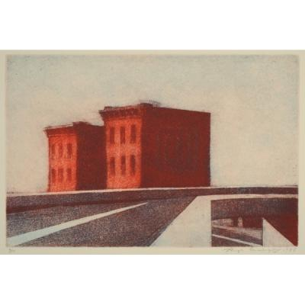
Expressway Ramps and Buildings by Hugh Mackenzie, 1983

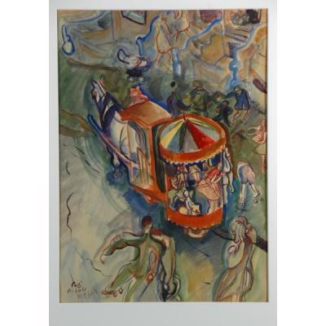

The Two Cent Ride by Pegi Nicol Macleod, n.d.

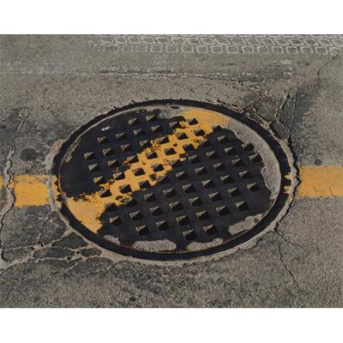
Broken Line #14 – Kelly Mark, 2003

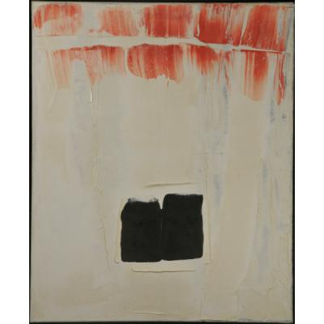

Untitled – Paul-Emile Borduas, 1959

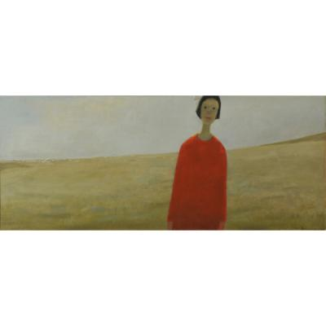
L’Ete –Jean-Paul Lemieux, 1959

Old/Used magazines
Oil Pastels
White Paper
Construction Paper
Glue sticks
Tissue Paper
Scissors (optional)

Strategies
Introduction:
The teacher will ask students what they believe emphasis means. The teacher will then ask how emphasis can be used in art. Students will then be introduced to the principle of emphasis. The teacher will have a class discussion about how emphasis is used in each of the Museum London artworks. Students will then be asked to break into groups to discuss how emphasis is used in ads in magazines. Students will flip through magazines in small groups and find one ad that displays emphasis and present it to the class briefly.
Climax:
Students will create individual artwork using oil pastels, construction paper and/or tissue paper, and glue to create an artwork using the principle of emphasis.
Conclusion:
Students will make a brief presentation of their artwork to the class, demonstrating where they used emphasis, and how they created the emphasis.

