Lesson Plan Information
Subject: Visual Arts | Name:
Grade: Three | Date: | Time:
Topic: Variety | Period Length:

Expectations
Curriculum Expectations (Based on the Ontario Curriculum Documents):

Learning Skills (Where necessary):

Content
What learners will know/be able to do:
Learners will discuss the elements of art and be introduced to the principle of art called variety. Students will be able to identify variety in artwork, and be able to create variety of their own in their artwork.
Today learners will:

Assessment and Evaluation
Determining student understanding:
Students will demonstrate understanding by creating artwork using at least two elements of art such as line, shape, form or colour. They will use markers and a standard printer-sized paper to draw a picture that can be abstract or realistic, using variation of two elements. Students will be expected to fill the page, and to not leave abundant white spaces.

Perspective
Necessary Prior Knowledge:
Students should already know the elements of art, though review may be necessary, and will concentrate on the principle of art “variety” in grade 3.
ELEMENTS OF DESIGN
Students will develop understanding of all elements of design.
• line: variety of line (e.g., thick, thin, dotted)
• shape and form: composite shapes; symmetrical and asymmetrical shapes and forms in both the human-made environment and the natural world (e.g., symmetrical: insects, flowers, skyscrapers; asymmetrical: windblown trees, some contemporary additions to buildings [asymmetrical façade in Daniel Libeskind’s design for the Royal Ontario Museum])
• space: foreground, middle ground, and background to give illusion of depth
• colour: colour for expression (e.g., warm and cool colours); colour to indicate emotion; mixing of colours with white to make a range of warm and cool tints
• texture: real versus visual or illusory texture (e.g., smooth surface of a ceramic work versus drawing of rough tree bark); etching by scratching through surfaces (e.g., crayon etching on a scratchboard)
• value: mixing a range of light colours and dark colours
PRINCIPLES OF DESIGN
Students will develop understanding of all principles of design (that is, contrast, repetition and rhythm, variety, emphasis, proportion, balance, unity and harmony, and movement), but the focus in Grade 3 will be on variety.
• variety: slight variations on a major theme; strong contrasts (e.g., use of different lines, shapes, values, and colours to create interest [bright or light colour values, dark colour values])
*Variety is the use of a wide range of elements of art. A painting using a lot of variety will have an abundance of different colours, an assortment of lines (thick, thin, curved, diagonal, vertical horizontal, etc.), variety may also have many different kinds of shapes or forms.
Differentiation:
Visually impaired students may discuss how variety in daily routines, or in friends and toys can result in a more exciting and interesting life.
Students with small motor skills challenges may elect to create a collage on the computer or cut and paste photos from magazines into a collage in order to demonstrate variety.
Environment:
Students will be seated at their desks in their normal classroom atmosphere.
Resources/Materials:

Museum London Artworks:
(the following artworks can be accessed by going to the Museum London website http://museumlondon.ca/ and searching for them on the “collections” page – type in the names of the artists)

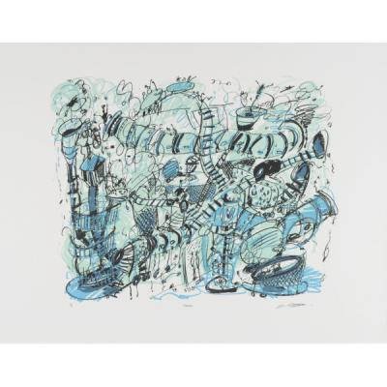
Parkade by Kim Adams, 1998 (variety in line and shape)

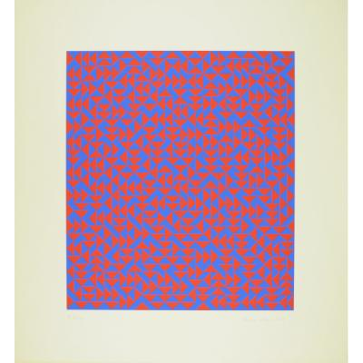
Untitled D by Anni Albers, 1969 (variety in shape and colour)

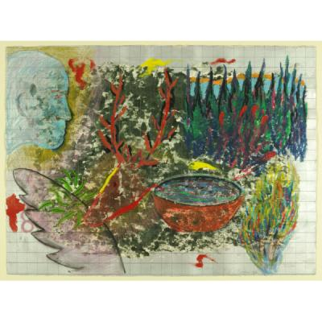
Untitled by Michael Amar, 1997 (variety in colour, line and shape)

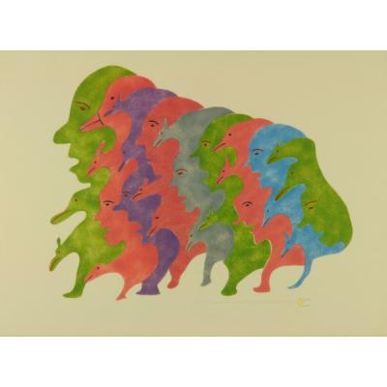
All Different Thoughts by Irene Avalahiak, 1978 (variety in line, colour and shape)

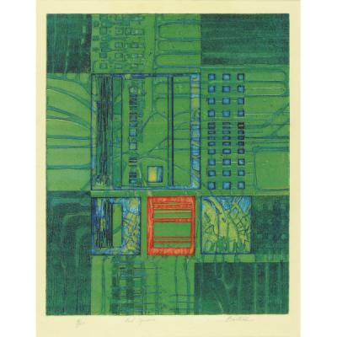
Red Square by Edward Bartram, n.d.

White paper
Markers
Construction Paper (optional, for framing artwork)
Rulers (optional)

Strategies
Introduction:
The teacher will ask students to explain each element of art, and will ask them to discuss where they see the elements of art in their school (book illustrations, posters, class decorations, student artwork, etc).
Climax:
Students will be introduced to the principle of art known as variety. Students will be asked what they think variety means, and the teacher will show variety through an element of art. It is easiest to show with line, as you can quickly draw fat lines, thin lines, curvy lines, zig-zag lines, straight lines, broken lines, diagonal, horizontal and vertical lines, etc.
Conclusion:
Students will draw a picture demonstrating variety using markers on a white sheet of paper. They must show variety using at least two elements of art, like line and colour. They will use the artwork Red Square by Edward Bartram, n.d. as a model.

