Grade: 2 Strand: Visual Arts Elements of Design: Line, Colour, and Space Principle of Design: Repetition Length:
What Will You Teach?
Expectations
- D1.2 Demonstrate an understanding of composition, using principles of design to create a narrative artwork
- D1.4 Use a variety of techniques to respond to a drawing design challenge (using contrast in size and placement on the paper to show depth of space)
- D2.2 Explain how elements and principles of design are used to communicate meaning or understanding in their own and others’ artwork (the use of different colours for achieving different effects, such as warm, sunny colours for a beach or cool colours for a wet forest)
- D2.4 Identify their strengths, what they feel they have done well, and what they would do differently next time to improve
learning goal
- I am learning to explore the elements of line, colour, and space so that I can draw a landscape that shows depth and tells a story
Success Criteria
- I can create a horizon line
- I can create depth by placing objects in the foreground, middle ground, and background
- I can use warm and/or cool colours to show the temperature

Materials and/or Resources
- White paper, pencils, erasers, pencil crayons, paint, paint brushes
- Artworks from Museum London Visible Storage Collection (accessed through http://visiblestorage.ca/)
Lake Huron No. 3 Pacific Breakers, British Columbia Lake Agnes above Lake Louise, Rocky Mountains
-- Jack Chambers – Frederic Marlett Bell-Smith -- Lawren Harris

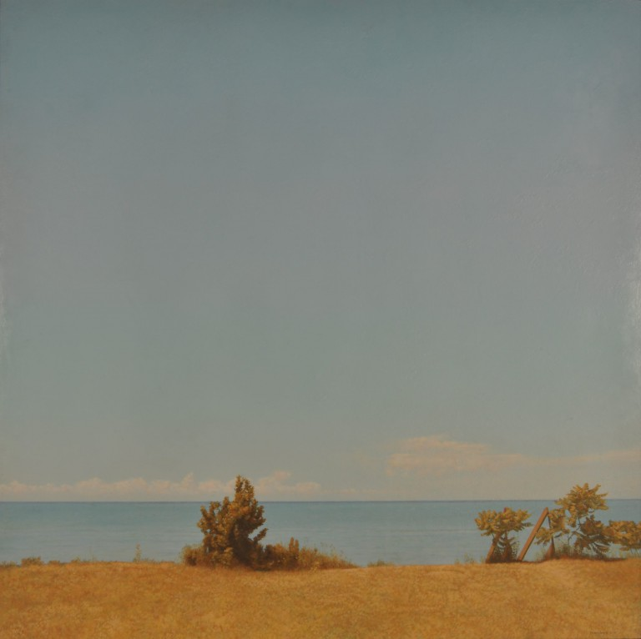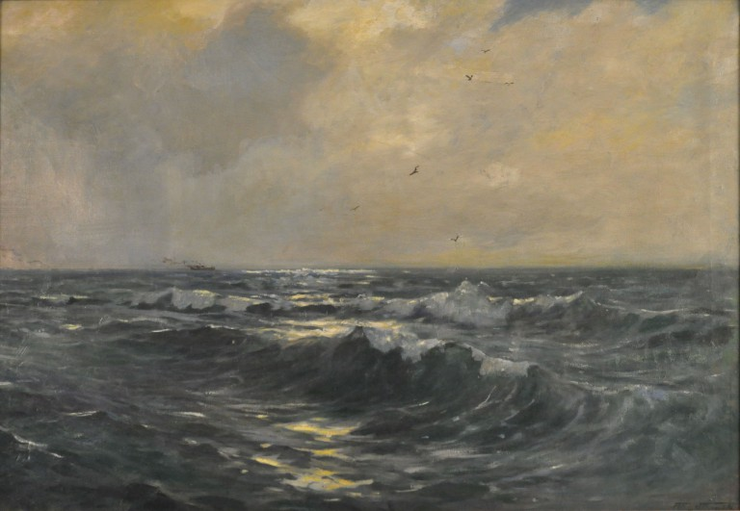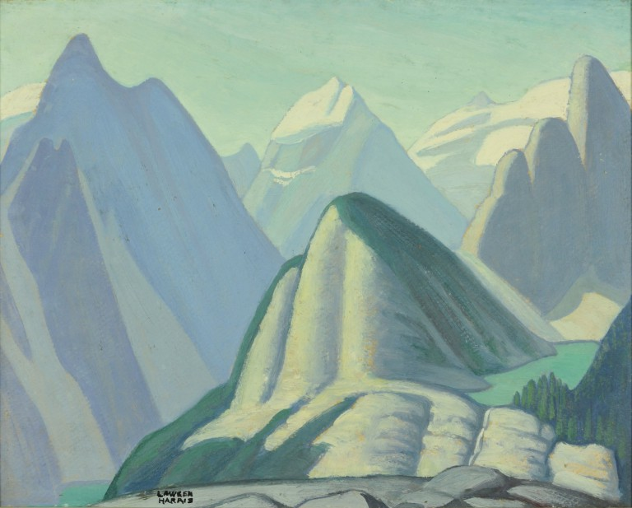

Important Terminology/Word Wall Words
- Depth, horizon line, foreground, middle ground, background, landscape
  - Visuals can be added beside the terms
How Will You Teach This? | Task & Assessment
Minds On!  - Reflect on the significance of colour, consider how colours make us feel (red=angry, hot; blue=sad, cold) and expand on warm versus cool colours. Students may take a paper and divide the paper in half. Draw the same scene on one side of the paper on the other. One side will be painted using warm colours and the other with cool colours.  - Observe two paintings that show two different landscapes (include a variety of horizon lines: high, low, flat, and jagged). Think-Pair-Share: the students discuss what they see in the paintings (What kind of lines? What are the colours used? Are there trees, people, and water?). Return to whole group and write observations on the board.  - Discover and explore how different horizon lines often represent the setting (straight line – beach, prairie; jagged line – mountain). Are there more natural objects in the scenery? Ask if anyone knows the term we use to refer to these paintings/pictures that include trees, land, water, flowers, or other natural scenery. Introduce the term landscape. | - Students will use a large paper and fold it in half. One side of the paper will be used to create a warm picture and the other side will be a reflection of the other side but use cool colours.  - Assessment for learning – document prior knowledge and adjust based on the needs of the student
Lesson Overview  The students will be introduced to the techniques artists use when creating landscape paintings by focusing on the illusion of depth.  Cementing the Knowledge.  - Discuss why artists paint landscapes. *Potential for artist study on the Group of 7. Landscapes often capture the mood of nature. By looking at paintings of landscapes, we can start to imagine what it would be like if we were to jump inside of the picture (compare landscapes between Chambers and Bell-Smith – Which landscape would you rather be part of and why? How does it make you feel?).  - Artists use “space tricks” to help us look at the flat surface (paper/canvas) and see a 3D world. It means that they can create a sense of depth or space.  - A winding path (road or river) that travels through the foreground to the background  - Changes in size (the object that is close to us looks much larger than the object of the same size that is far away)  - Overlap (an object that is closer to us partially hides a much larger object behind it)  - Take a look at a variety of landscape paintings. Students will find and describe some of the “space tricks” the artist used. Explain that artists use another technique to create depth by dividing the scene into three sections: foreground, middle ground, and background. In pairs or small groups, have the students identify each section in a series of pictures (hard-copy or on the SMART board).  Activity: Students will use a pencil to draw three (slight) diagonal lines. They must draw at least three shapes (trees, plants, hills, or mountains, etc.) with one extending up from each line. Hint: Objects in the foreground will appear larger than in the middle- or background. Students may erase the ground lines within each object. Outline all pencil lines with a black marker (outline only). Paint the picture to reflect the mood of the scenery (warm/cool colours).  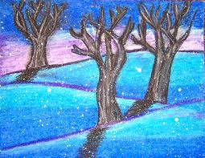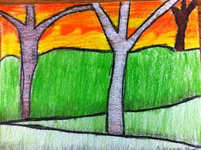  Critical Analysis Project (Option for artist study: Lawren Harris painting)  Initial Reaction  - what is your first impression?  - what does this work bring to mind?  Description  - what elements and principles of design do you notice?  Analysis and Interpretation  - how does the image make you feel?  Expression of an informed point of view  - In what ways was the piece of art successful? | - Observe and document understanding throughout the process (tick-tick-tick assessment). Adjust lesson to meet the needs of the students as necessary  - Students will use a large paper and fold it in half. One side of the paper will be used to create a warm picture and the other side will be a reflection of the other side but use cool colours.  - Success Criteria
Consolidation  The Beautiful Project  - The final project will be open-ended to allow students to use the information they have learned throughout the unit, techniques they have discovered and explored to create a landscape  - Students are given a piece of paper and asked to create any landscape that showcases foreground, middle ground, and background (use pencil crayons)  - After the gallery walk, encourage the students to share and communicate with the rest of the class some of the stories they noticed | - Assessment of learning:  - All components of the success criteria  - Use of qualifiers  - Descriptive feedback  - Gallery walk (anecdotal notes)

