Lesson Plan Information
Subject: Art | Name:
Grade: One | Date: | Time:
Topic: Elements and Principles of Design | Period Length:

Expectations
Curriculum Expectations (Based on the Ontario Curriculum Documents):
Visual Arts:
D1.3 Use elements of design in art works to communicate ideas, messages, and personal understandings (e.g., a pattern of broken, wavy, and zigzag lines to make the bark of a tree look rough in a drawing; size and arrangement of organic shapes in a painting of flowers to create the impression that the various flowers are at different distances from the viewer)
D2.1 Express their feelings and ideas about art works and art experiences (e.g., describe feelings evoked by the use of colours in the paintings provided)
Learning Skills (Where necessary):

Content
What learners will know/be able to do:
Recognize and apply the elements of design and the principle contrast:
ELEMENTS OF DESIGN
Students will develop understanding of all elements of design.
• line: jagged, curved, broken, dashed, spiral, straight, wavy, zigzag lines; lines in art and everyday objects (natural and human-made)
• shape and form: geometric and organic shapes and forms of familiar objects (e.g., geometric: circles, blocks; organic: clouds, flowers)
• space: depiction of objects in the distance as smaller and closer to the top of the art paper; shapes and lines closer together or farther apart; horizon line; spaces through, inside, and around shapes or objects
• colour: mixing of primary colours (red, yellow, blue); identification of warm (e.g., red, orange) and cool (e.g., blue, green) colours
• texture: textures of familiar objects (e.g., fuzzy, prickly, bumpy, smooth); changes in texture; a pattern of lines to show texture (e.g., the texture of a snake’s skin); transfer of texture (e.g., placing a piece of paper over a textured surface and then rubbing the paper with wax crayon)
• value: light, dark
PRINCIPLES OF DESIGN
Students will develop understanding of all principles of design (that is, contrast, repetition and rhythm, variety, emphasis, proportion, balance, unity and harmony, and movement), but the focus in Grade 1 will be on contrast.
• contrast: light/dark; large/small; pure/mixed colour
Today learners will:
Review the elements of design and the principle of contrast. Observe the artwork from Museum London and have a class discussion about each piece, identifying the elements and if contrast is used. The students will listen to two songs of their teacher’s choice. Students will then draw two pictures, one representing each song. Their pictures will show contrast (refers to the arrangement of opposite elements (light vs. dark colors, rough vs. smooth textures, large vs. small shapes, etc.) in a piece so as to create visual interest, excitement and drama. The colors white and black provide the greatest degree of contrast. Complementary colors also highly contrast with one another.) along with at least one element of art (line, shape and form, space, colour, texture and value).

Assessment and Evaluation
Determining student understanding:
Student artwork will represent at least one element and the principle of contrast. It will represent each song and can be either realistic or abstract. The art will be assessed using a checklist which checks for completion, elements, contrast, and effort.

Perspective
Necessary Prior Knowledge:
Students should already be aware of the elements of design, but teacher will refresh their memory on the elements and the principle of contrast.
Differentiation:
Visually impaired students: Have the student listen to music and describe the way it makes him/her feel. Write about what the rhythm is like, and why they like or do not like the song.
Impaired motor skills: Student(s) may cut and paste an example of each element from magazines, newspaper ads, and internet photos; and show an example of contrast as well.
Environment:
Classroom setting, use of overhead projector or Smart Board
Resources/Materials:
Overhead projector/Smart Board for showing artworks
CD Player or radio with music
White Paper
Pencils
Crayons/Paints/Pencil Crayons

Museum London Artworks:
(these artworks can be accessed by going to the Museum London website http://museumlondon.ca/ and searching for them on the “collections” page – type in the names of the artists)
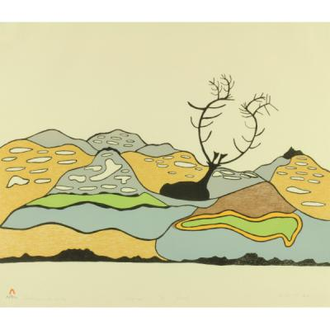
Landscape with Caribou by Padlo, 1977

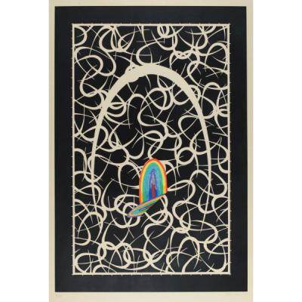
The Hook by Lucas Samaras, 1972
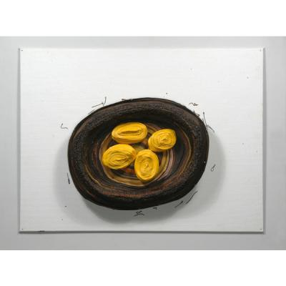
Still Life With Four Lemons by Mary Scott, 1980

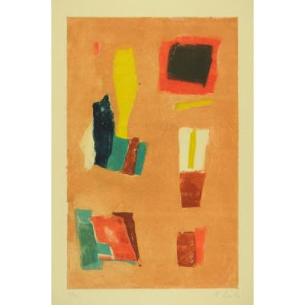
Untitled by Lafatie, n.d.

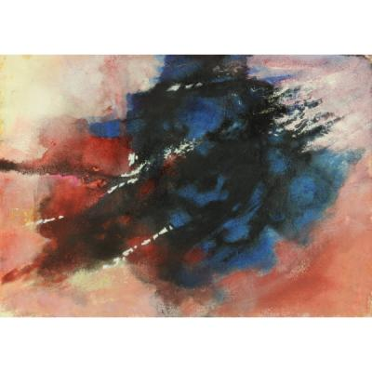
Untitled Abstract by James Kemp, 1967

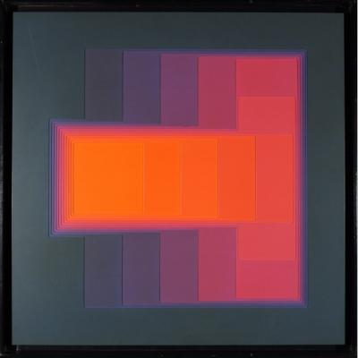
Colour Sound I by Karl Gerstner, n.d.

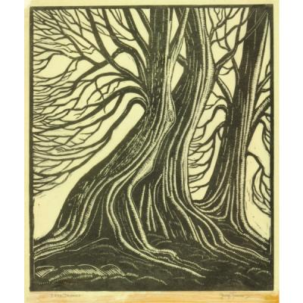
Tree Trunks by George Turner, 1942

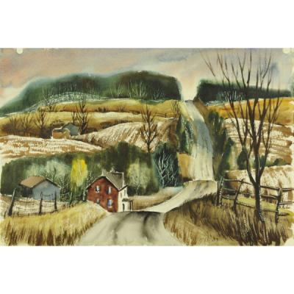
Country Road by George Eitel, n.d.

Strategies
Introduction:
Ask students to name the elements of design. Discuss what each element is. Introduce the principle of contrast.
Climax:
Show students each artwork listed under resources and discuss as a class which elements each artwork uses, and whether it uses contrast. Discuss how these elements and principles make the artwork have a certain mood or feeling.
Conclusion:
Students will create a picture that represents their favourite song using at least 2 elements of design and the principle of contrast. The picture can be realistic or abstract, but must convey a mood.

