Create an Animal Using Texture, Line and Shape, Grades 1-3 Museum Collection Artwork: Red Owl by Tye Adla, 1969
Lesson developed by Sarah Elminshawi
What Will You Teach?
Expectation(s): Strand:
- demonstrate an understanding of composition, using principles of design to create narrative art works or art works on a theme or topic
- use elements of design in art works to communicate ideas, messages, and personal understandings
- use a variety of materials, tools, and techniques to respond to design challenges
- (in the case of reflection time) explain how elements and principles of design are used to communicate meaning or understanding in their own and others’ art work
Learning Goal (student-friendly language that can be shared with students): You will be drawing your own animal using different lines, shapes and textures

Materials and/or Resources: Paper, crayons, pencils, markers, pens, paints. The teacher can use the type of medium they wish, depending on availability and what works best for the class.

Important Terminology / Word Wall: Texture, smooth, rough, scaly, feathery, hard, soft, fluffy line, dotted line, wavy lines, short/long lines, thick/thin lines, organic shapes, geometric shapes

How Will You Teach This? | Assessment for learning
Minds On! The artwork that is to be created is based on a Museum London artwork titled Red Owl by Tye Adla, 1969. This artwork can be introduced at the beginning of the lesson and used as an exemplar for students once you introduce the culminating activity.  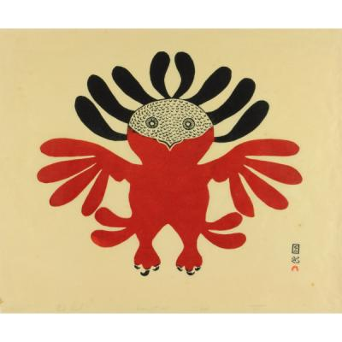  (this artwork can be accessed by going to the Museum London website http://museumlondon.ca/ and searching for it on the “collections” page – type in the title of the artwork Red Owl.) | Diagnostic: Students will be introduced to line and shapes in this lesson. The teacher can choose whether they would like to create a slide for this lesson or if they will demonstrate line and shape and creating texture by drawing examples of these elements and how to use them on a chalkboard, paper or projector.
Lesson Overview (sequence of lesson steps – the Action as students create, produce, demonstrate and respond) + Key Questions (that you might ask as the lesson develops):  1-2 40 minute classes:  In this lesson you will be introducing line, texture and shape to the students, based on the artwork Red Owl by Tye Adla. This artwork shows organic shape and line to create texture. The following are the elements of art that you will emphasize with the class and encourage them to use in the culminating art project:  - Line: dotted, wavy, curved, thick, thin, short and long. Discuss how creating these various types of line create shapes and textures.  - Texture: show how using different types of line create these types of texture: smooth, rough, fluffy, feathery, hard, soft, etc.  - Shape: organic: natural, curved shapes that would occur in nature, such as an apple, pear, or animal shape. Geometric: shapes that can be defined, such as squares, circles, pentagons, rectangles, etc.  - Once you have completed the lesson in teaching the students these elements of art you can then assign the culminating activity: Creating An Animal Using Line, Shape and Texture  - Encourage the students to create their own animal picture using organic and geometric shapes while using an assortment of lines to create various textures.  - The teacher may choose to have specific expectations for this assignment, such as: At least one organic shape and one geometric shape, and at least three different textures by using a variety of lines. This assignment can be modified depending on the needs of the classroom  - Medium choice is also up to the teacher, though this will be effective as a drawing assignment. Use of pencil, crayons, pens, markers and even paints on paper can be effective for this assignment as well. | Formative: In the creative process, students demonstrate understanding through creating organic and geometric shapes, texture and line variations.
Consolidation (reflecting, presenting, sharing, growing, adapting)  The teacher may choose to have a presentation time allotted for the end of the assignment, a simple discussion about the works the students have created, what they like about their work, how they used the elements, and what they might do differently if they did this assignment again. This gives students a chance to reflect on their work and provide and receive feedback to/from their peers, as well as reflecting on the creative process in their own work. They also practice forms of presenting such as preparation, public speaking, and eye contact when presenting to groups. | Summative: Students present their work in presentations and provide rationale for their creative choices while sharing their creative process. By answering guiding questions through the presentation process, students reflect on their work as well as provide feedback to their peers.

